Jira Kanban Task Creation - Step by Step with Screenshots

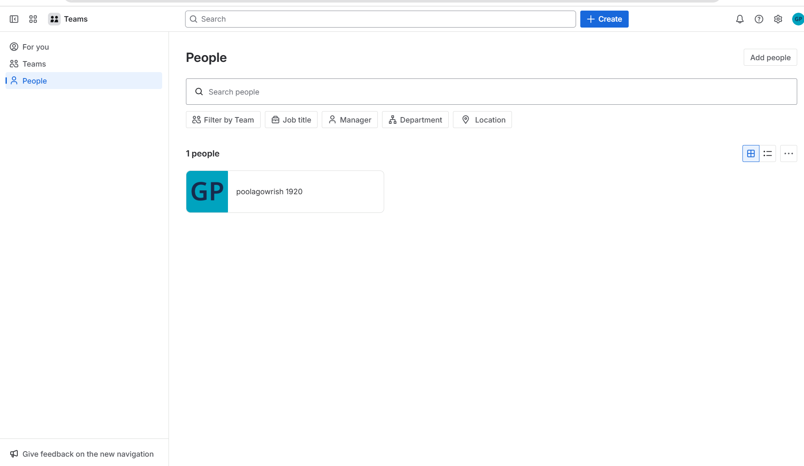
Step 1: Open Jira and go to the Teams section from the left panel.
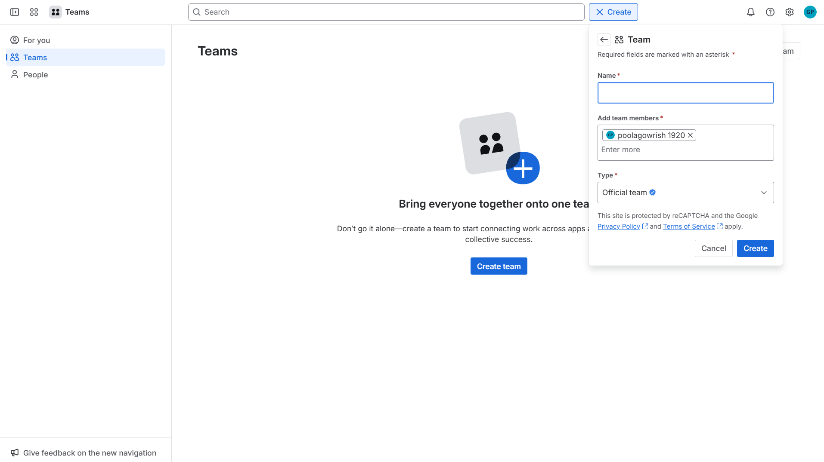
Step 2: Click on Create button and choose Team to create a new team and add names.
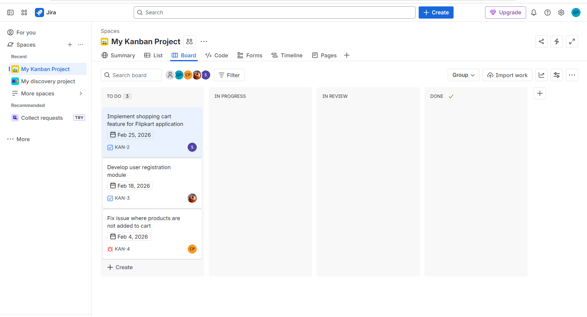
Step 3: there is a create button on the top. Click to create a new project.
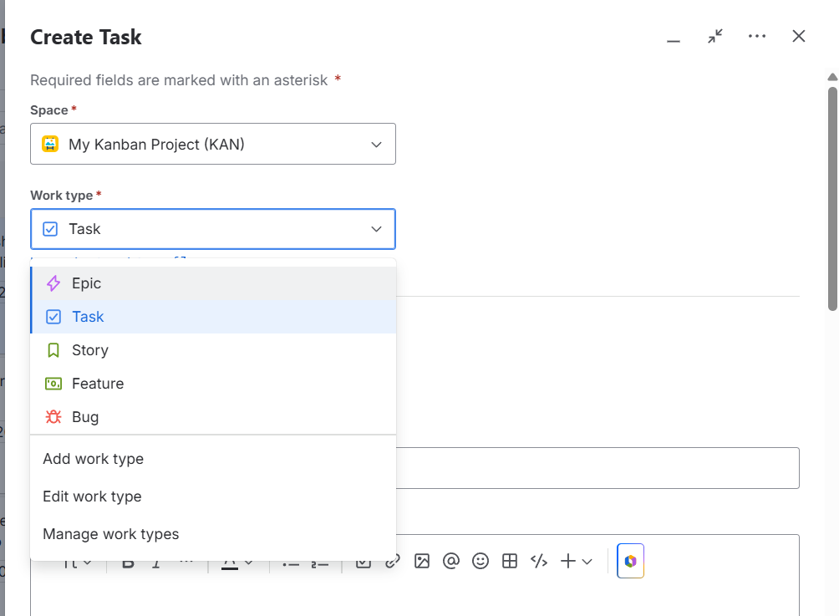
Step 4: Open My Kanban Project from Spaces, then select the work type.
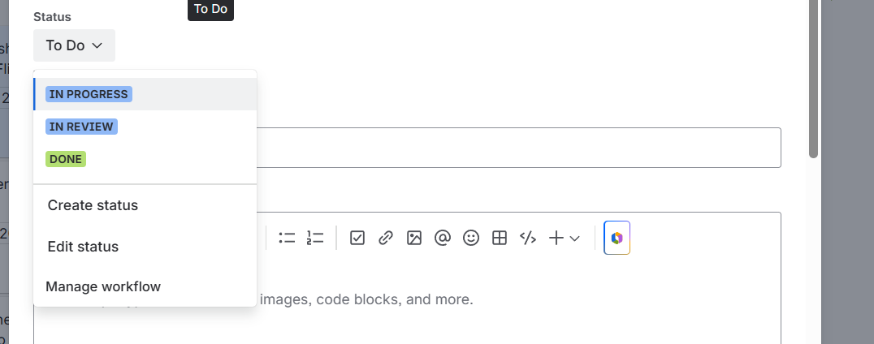
Step 5: Select the status as TO DO
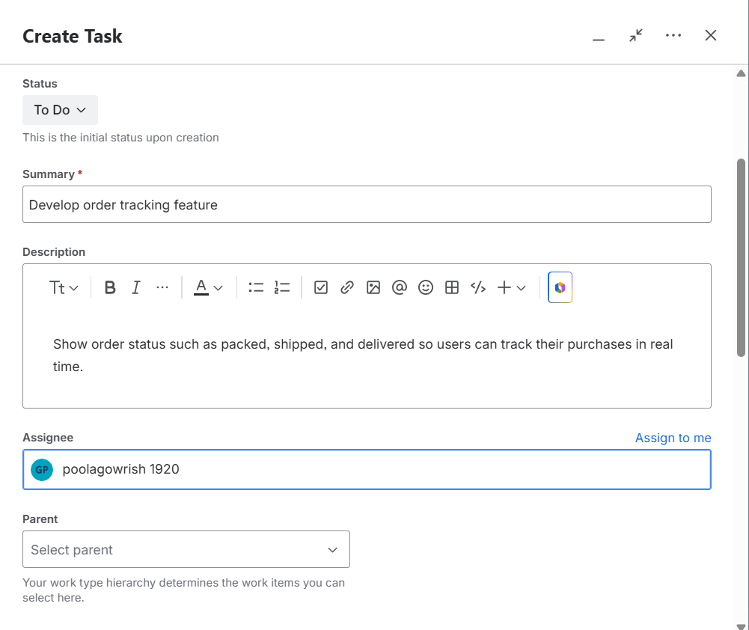
Step 6: add summary and descriptions of the task.
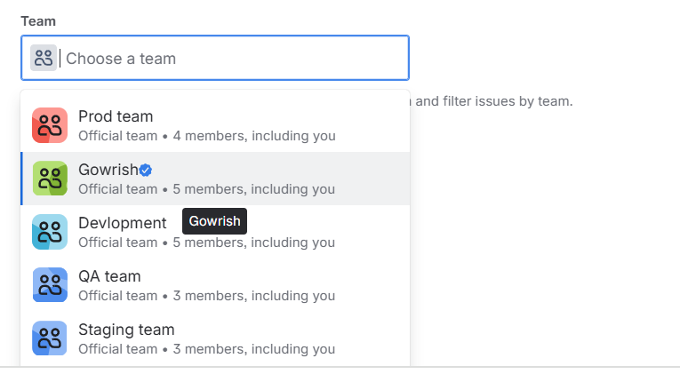
Step 7: Select the team to assign the task and give a person name as incharge.
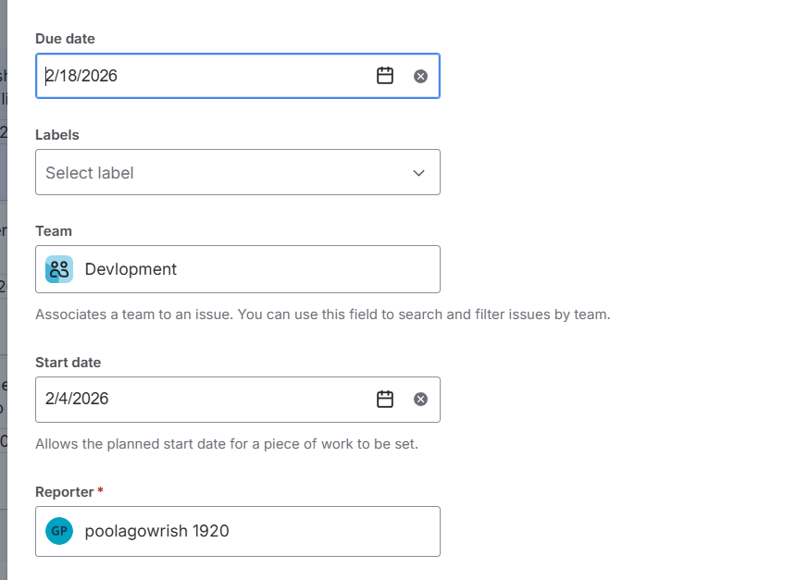
Step 8: Add start date and Due date.
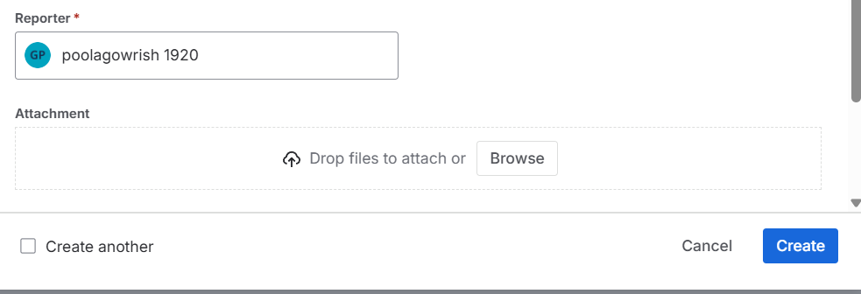
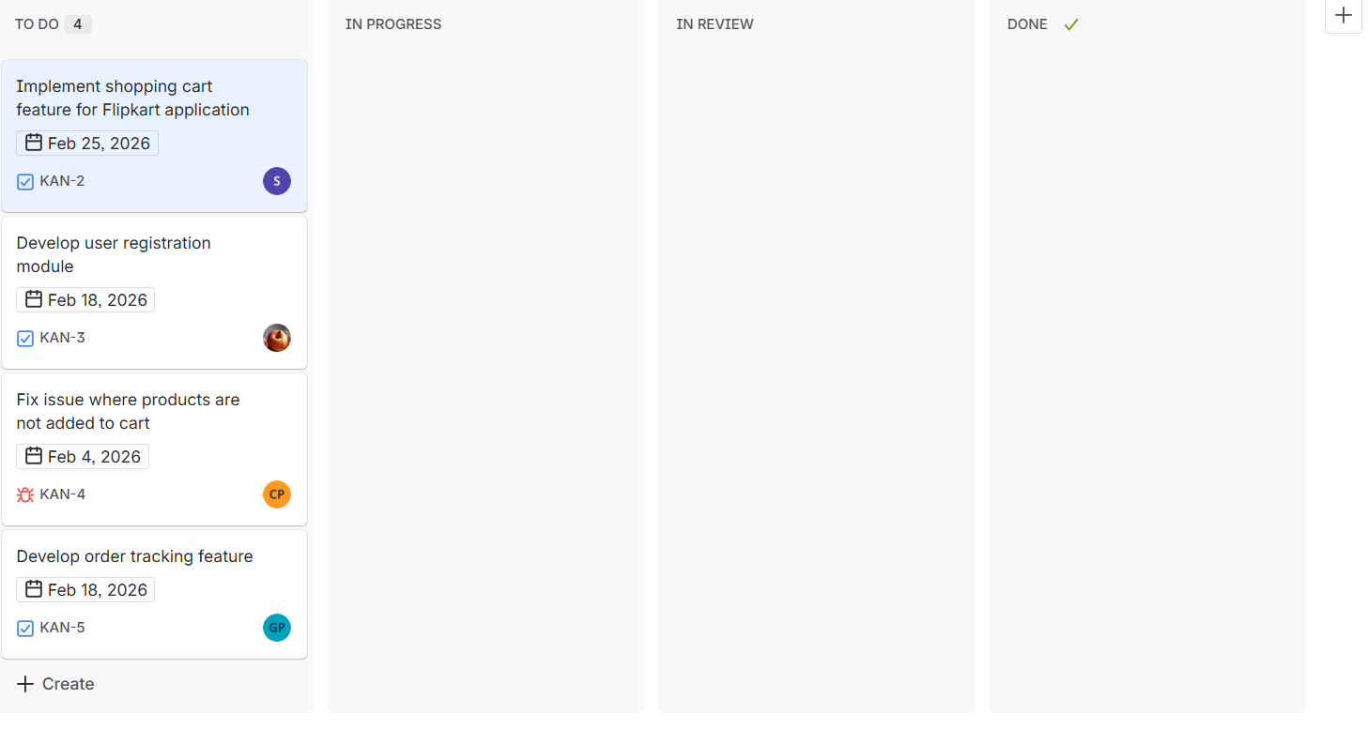

Step 9: select the reporter and click on create. The task will be assigned. And you can see the tasks to do , in progress, in review and Done.

Step10: if you want add comments we can add comments and they can reply to the comments.
